KPMG Challenge –

Challenge #1

A 3-tier environment is a common setup. Use a tool of your choosing/familiarity create these

resources in a cloud environment (Azure/AWS/GCP).

Ans: - Web-Apps can be implemented in several ways, below is Sample implementation of a 3- tier architecture.

In the below, the Web and Apps deployed using simple IAAS services and for the Data layer used a PAAS implementation of Data base.

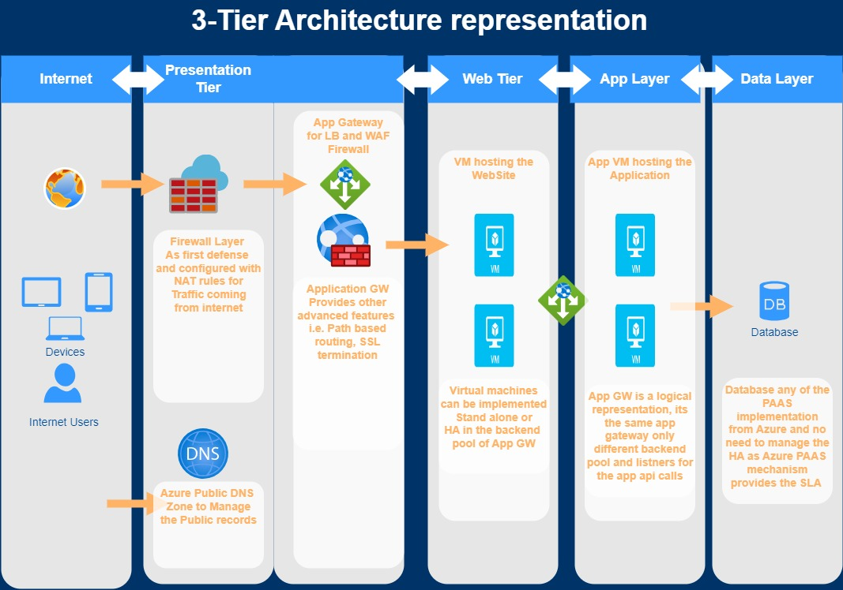

Challenge #2

We need to write code that will query the meta data of an instance within AWS or Azure or GCP

and provide a json formatted output.

Ans: - In Azure Cloud the meta service end points can be accessed with in the virtual machines and below python code can fetch the information in JSON formatted output.

“”

**i.e,. Python SDK’s**

import requests

import json

metadata_url = 'http://169.254.169.254/metadata/instance?api-version=2021-02-01'

headers = {

    'Metadata': 'true'

}

response = requests.get(metadata_url, headers=headers)

metadata_json = response.json()

formatted_output = json.dumps(metadata_json, indent=4)

print(formatted_output)

Challenge #3

We have a nested object. We would like a function where you pass in the object and a key and

get back the value.

* Example Inputs

object = {“a”:{“b”:{“c”:”d”}}}

key = a/b/c

In the below program takes the Key’s in the combination of the nested architecture and provides the output.

def get_value_from_nested_object(obj, key):

    keys = key.split('/')

    value = obj

    try:

        for k in keys:

            value = value.get(k)

            if value is None:

                return None

        return value

    except (AttributeError, TypeError):

        return None

obj = {"a": {"b": {"c": "d"}}}

key = "a/b/c"

value = get_value_from_nested_object(obj, key)

print(value)

In case if the value is required with the Specific Key in the nested structure, then

def getvaluefromobj(obj, key):

    if isinstance(obj, dict):

        if key in obj:

            return obj[key]

        else:

            for value in obj.values():

                result = getvaluefromobj(value,key)

                if result is not None:

                    return result

    return None

obj = {"a": {"b": {"c": "d"}}}

key = "d"

value = getvaluefromobj(obj, key)

print(value)